A QUANTITATIVE ANALYSIS OF CANDIDATES IN THE 2019 LOK SABHA

1. INTRODUCTION:

General elections were held in India in seven phases from 11 April to 19 May 2019 to elect the members of the 17th Lok Sabha. Votes were counted and the result was declared on 23 May. The election resulted in a landslide victory for the BJP which won 303 seats and formed the government.

* OVERVIEW:

The election resulted in a landslide victory for the BJP which won 303 seats and formed the government. Around 912 million people were eligible to vote, and voter turnout was over 67 percent – the highest ever, as well as the highest ever participation by women voters.

* PURPOSE:

The Lok Sabha has certain powers that make it more powerful than the Rajya Sabha. Motions of no confidence against the government can be introduced and passed in the Lok Sabha. If passed by a majority vote, the Prime Minister and the Council of Ministers resign collectively.

* PROBLEM STATEMENT& DESING THINKING:

we have found few candidates with criminal history also. So through this data analysis, we can aware of the candidate's history as well as the nature of the political party. We can learn about the winning party and their success in 2019.

2.2 EMPATHY MAP

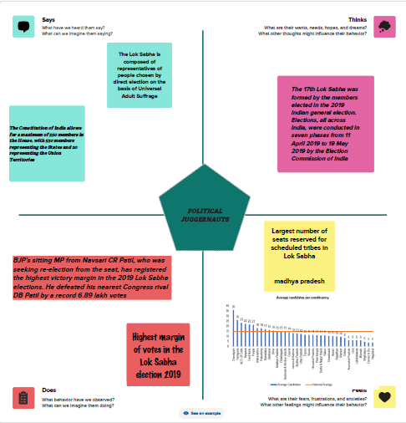

2.3 IDEATION&BRAINSTROMING

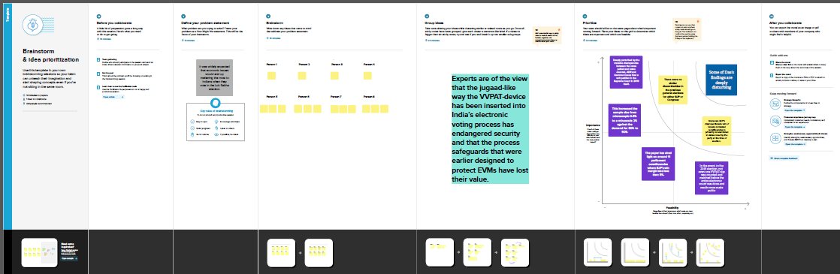

3.RESULT:

3.1 ANNUAL PAYROLL

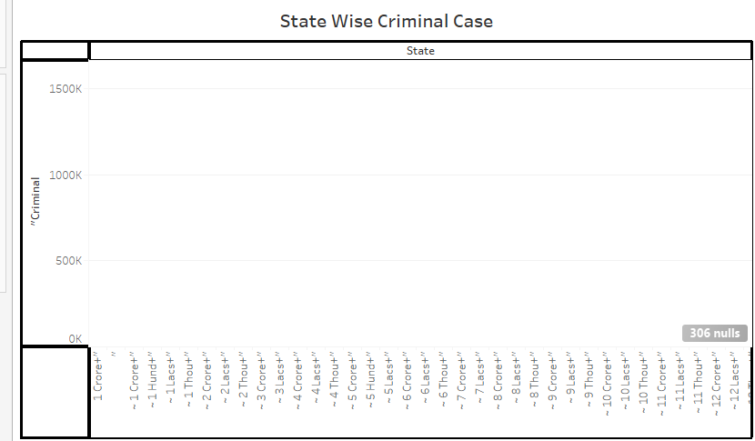

3.1.2 CONSTITUENCY WISE WINNER &TOTAL WINNER

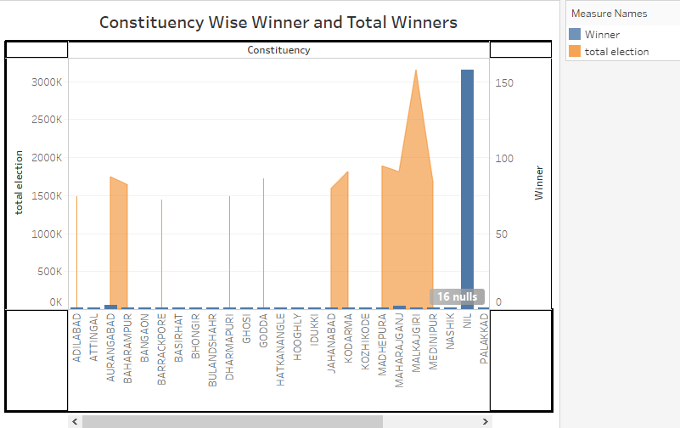

3.1.3 PARTY WISE WINNER

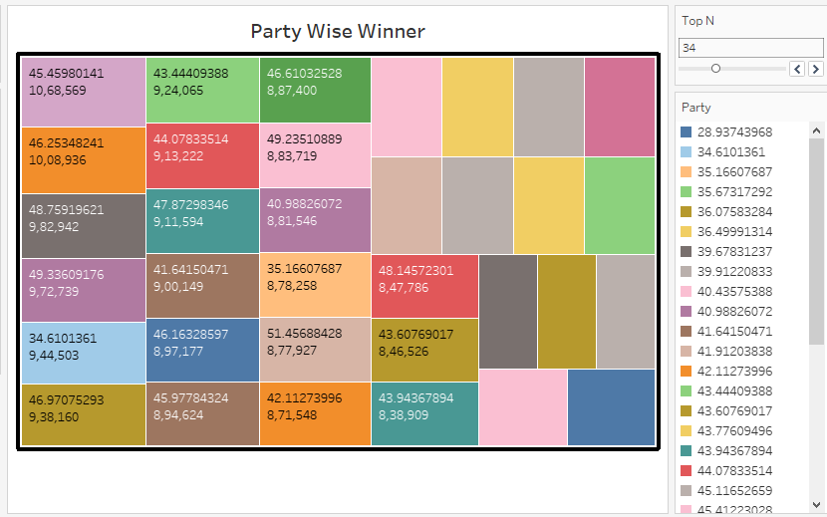

3.1.4 WINNERS BY EDUCATIONAL AND CATEGORY

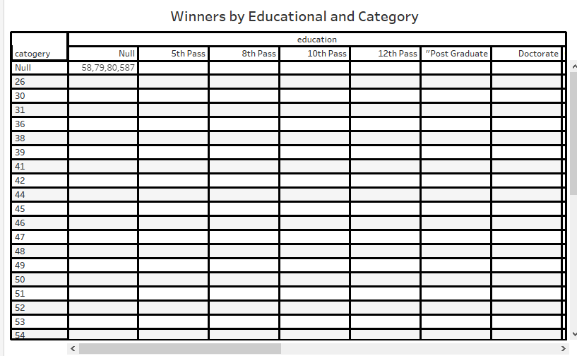

3.1.5 PARTY WISE POSTAL VOTES

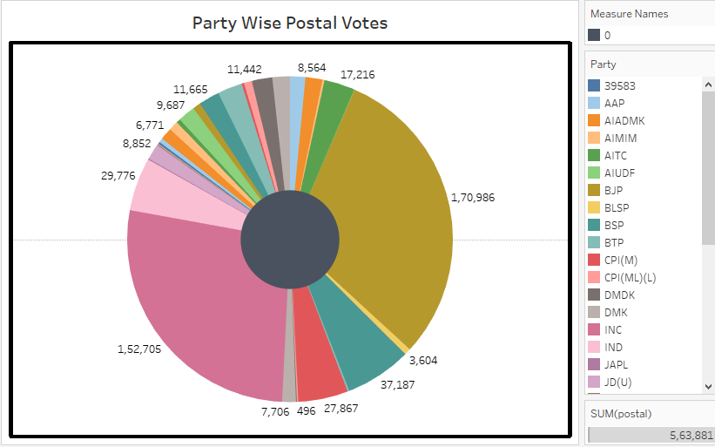

4. DASHBOARD:

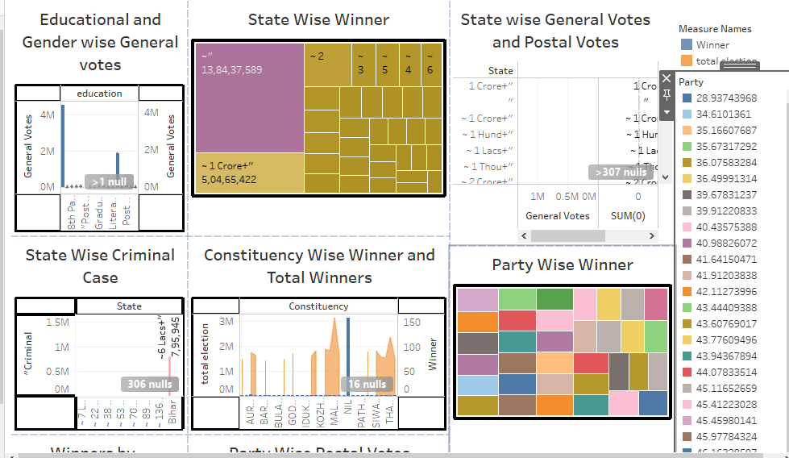

STORY 1:

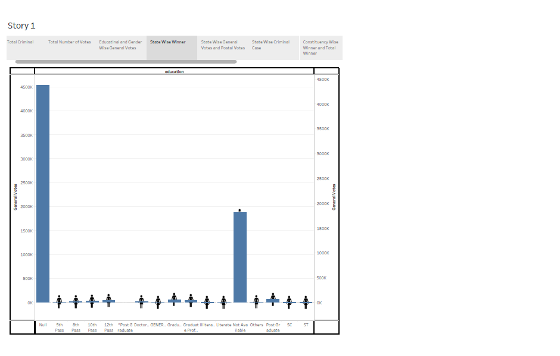

STORY 2:

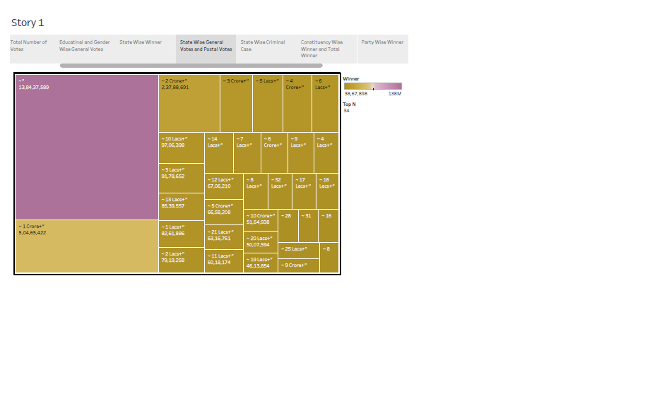

STORY 3:

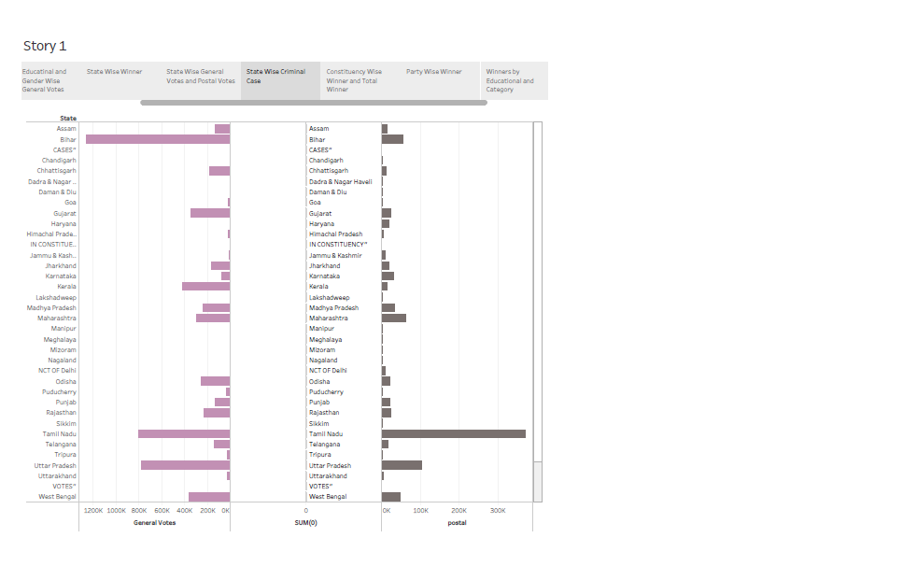

STORY 4:

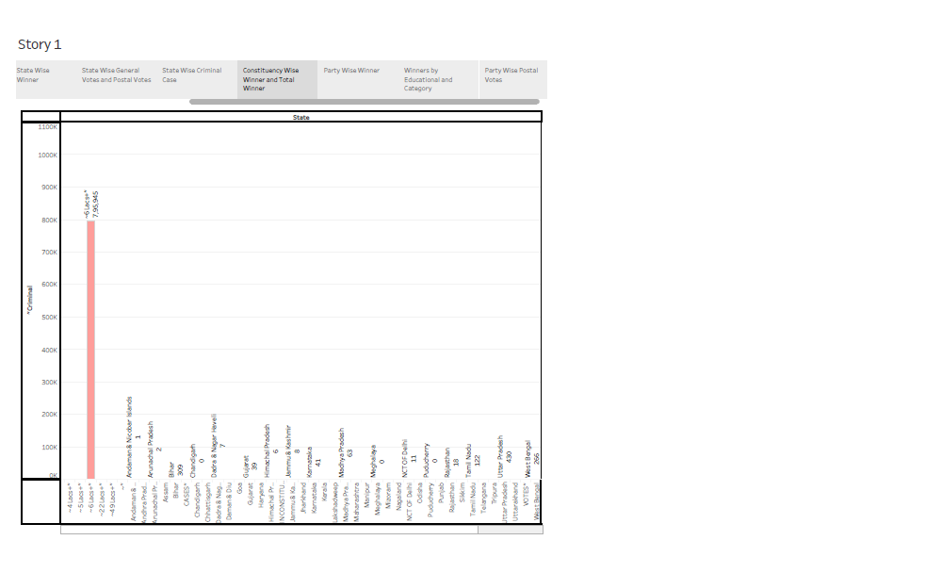

STORY 5:

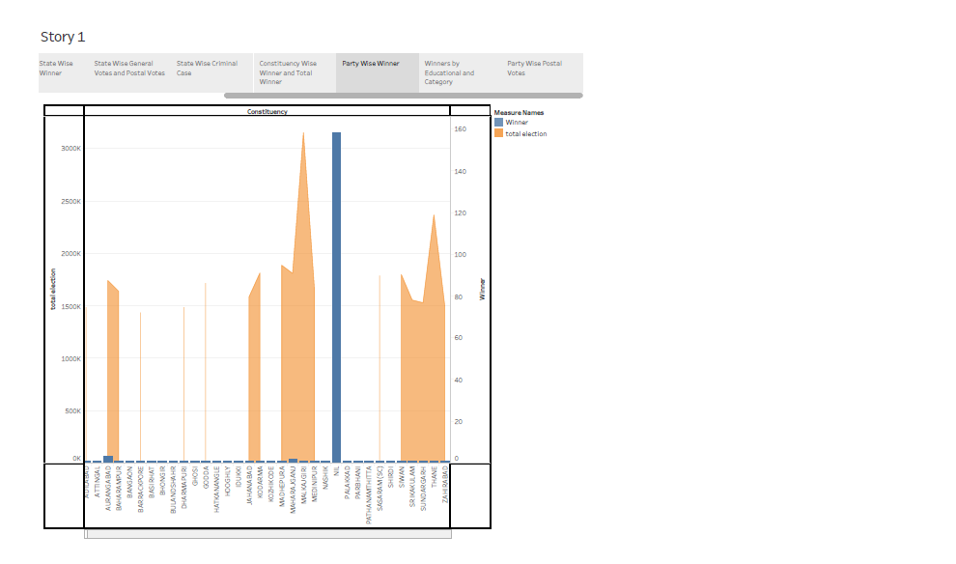

STORY 5:

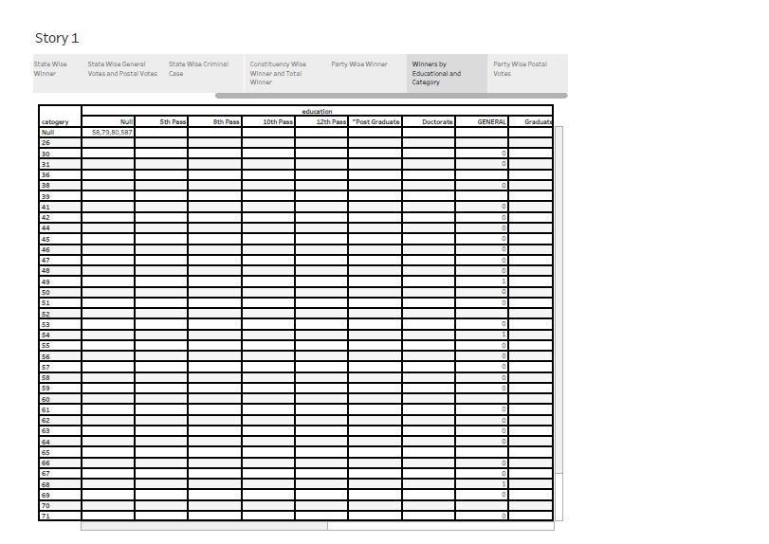

STORY 6:

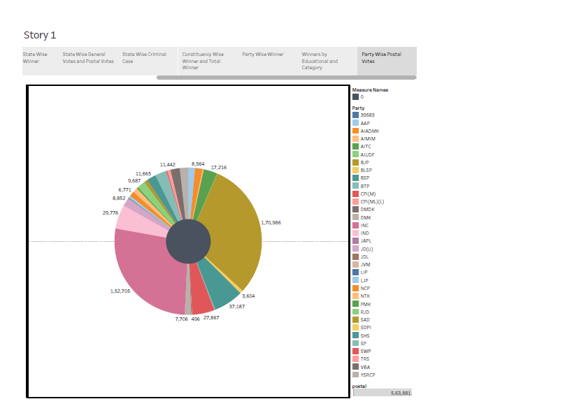

4.1 ADVANTAGES

1. The cost of elections and campaigning by parties which is so often higher than expected would be lessened to a good extent in the long run. In the elections of 2014, all the parties took turns at blaming each other on their source of funds for election campaigning. Some of them were ridiculously high. In a country where poverty is still is a major drawback, useless expenses on elections should be cut down and increasing the tenure of Lok Sabha seems a good way.  
  
2. Plans and strategies that are made by the government take time to yield result. The smart city plan, for instance, cannot be completed within the 5 years tenure of the government. First year was spent in deciding which cities would come under the plan. The next two years would be spent studying and surveying the cities to determine which plans and policies would work for them. When the final time for seeing the result of their efforts would be close, all their attention would shift to elections. Either the plan would be lost or interest in implementing would be lost owing to change in priority.  
  
3. Politicians usually have big ideas and plans at the time of elections. By the time they get the power, they also realize that they have only 5 years to reap the benefits of all the efforts they have put into the elections. Hence, they indulge in malpractices, scams and corruptions. Mostly politicians indulge in plans that would show the results sooner and not in the long run. Just to build their image in the eyes of public, they indulge in show off and actions that would only please a particular community which would later serve as their vote bank. Increasing the tenure to 7 years would have them relaxed and concentrate better on long term plans.  
  
4. We have seen the erstwhile government crying that the present government simply took credits for the work which they had begun years back. This at least wouldn't happen if tenure is increased to add two more years. There would be no complaining that there wasn't enough time to implement programs that they had begun. People would also get a better idea about the efficiency of a political party which would help them decide better in the next elections.

4.2 DISADVANTAGES

1. Increasing the term of Lok Sabha is simply giving more powers to the ruling party which already acts as king within the allotted time period. Atrocities will know no limits if politicians know that there would be no check on their powers for the next seven years. The significance of five years term is more than what we could decipher simply by taking into account expenditures and plans by the government.  
  
2. Five years is quite a reasonable period of time to show a good amount of work done by the ruling party so as to assure that they deserve to rule for another five years or so. If a government is unable to give this assurance to citizens in five years, it doesn't make any difference to them if they get another 2 years. It would get them indulging more ravenously in adding black money to their own accounts.  
  
3. Let's not forget that all the scams and corruptions that we are talking about happened not in five years tenure but in 10 years. The government obviously got more confidence than it deserved or needed. They could really believe that people are foolish enough and their deeds would never be uncovered. We are definitely not looking forward to giving this kind of powers to any political party in years to come.  
  
4. In the present scenario, ruling party has the fear of spoiling their image for the next election which is not very far. The erstwhile government, on the other hand, has enjoyed a whole five years and got re-elected for another five years which gave them the idea that they could go on being inactive without being noticed.

APPLICATION

**Half-an-Hour discussion:**

A half-an-hour discussion can be raised on a matter of sufficient public importance which has been the subject of a recent question in Lok Sabha irrespective of the fact whether the question was answered orally or the answer was laid on the Table of the House and the answer which needs elucidation on a matter of fact. Normally not more than half an hour is allowed for such a discussion. Usually, the half-an-hour discussion is listed on Mondays, Wednesdays, and Fridays only. In one session, a member is allowed to raise not more than two half-hour discussions. During the discussion, the member, who has given notice, makes a short statement, and not more than four members, who have intimated earlier and have secured one of the four places on the ballot, are permitted to ask a question each for further elucidating any matter of fact. Thereafter, the minister makes replies. There is no formal motion before the house nor voting.

**Discussion on matters of urgent public importance:**

Members may raise discussions on matters of urgent public importance with the permission of the Speaker. Such discussions may take place two days a week. No formal motion is moved in the House nor is there any voting on such a discussion.

**Debate in the House:**

After the member who initiates discussion on an item of business has spoken, other members can speak on that item of business in such order as the Speaker may call upon them. Only one member can speak at a time and all speeches are directed to the chair. A matter requiring the decision of the House is decided to employ a question put by the Speaker on a motion made by a member.

**Division:**

A division is one of the forms in which the decision of the House is ascertained. Normally, when a motion is put to the House members for and against it indicate their opinion by saying "Aye" or "No" from their seats. The chair goes by the voices and declares that the motion is either accepted or rejected by the House. If a member challenges the decision, the chair orders that the lobbies be cleared. Then the division bell is rung and an entire network of bells installed in the various parts and rooms in Parliament House and Parliament House Annexe rings continuously for three and a half minutes. Members and Ministers rush to the Chamber from all sides. After the bell stops, all the doors to the Chamber are closed and nobody can enter or leave the Chamber till the division is over. Then the chair puts the question for a second time and declares whether in its opinion the "Ayes" or the "Noes", have it.

CONCLUSION

It doesn't matter whether the tenure of office is five years or seven, what matters is a check on powers which is only possible if the tenure is short lived. The five years period has a good significance. It is neither too much to let the party take things for granted nor is it too less for parties to complain that they didn't get adequate time to implement their plans. Five years terms should neither be decreased nor increased. This time frame is reasonable enough to give ruling party a good opportunity to show the voters that there is scope for development and good times if they re-elect the same party.

FUTURE SCOPE

**Lok Sabha Elections**

The members of Parliament (MPs) are elected/appointed from states, union territories or are appointed from a field of particular expertise. The elections to Lok Sabha occur every 5 years in the name of general elections. The [Constitution of India](https://byjus.com/free-ias-prep/constitution-of-india-an-overview/) has adopted **universal adult franchise** as a basis of elections to the Lok Sabha and the state legislative assemblies.

**Representation of States in Lok Sabha:**

* Members are directly elected by the people from the territorial constituencies in the states
* Election Principle used – Universal Adult Franchise
* Eligibility to Vote: Any Indian Citizen of/above 18 years of age

**Note**: Voting age was reduced from 21 to 18 years by the 61st Constitutional Amendment Act, 1988.

**Representation of Union Territories in Lok Sabha:**

* Parliament is empowered to choose the members from the UTs in any manner as it desires
* Election Principle used – **Direct Election**

**Note**: **Union Territories (Direct Election to the House of the People) Act, 1965**, has been enacted by which the members of Lok Sabha from the union territories are chosen by direct election.

**Representation of Nominated Members in Lok Sabha:**

President nominates 2 members from Anglo-Indian Community if they are not adequately represented.

**Note**: The provision to nominate Anglo-Indians was extended till 2020 by 95th Amendment Act, 2009.

**Facts about Lok Sabha elections for UPSC**

* 1st Lok Sabha Election took place in 1952. There were 489 seats elected. Congress won 364 out of 489 seats. Jawaharlal Nehru became the first Prime Minister.
* 2019 Lok Sabha elections were country’s 17th General Elections. Elections took place for 552 seats. BJP won 303 seats out of 552. Narendra Modi is the Prime Minister.
* ]In 1952, only 22 women were elected while in 2014, 49 women candidates were elected.

APPENDIX

|  |  |
| --- | --- |
| **Amendment Act** | **Amended Provisions w.r.t. Lok Sabha** |
| 2nd Amendment Act, 1952 | Readjusted the scale of representation in the Lok Sabha |
| 23rd Amendment Act, 1969 | Extended the reservation of seats for the SCs and STs, and special representation for the Anglo-Indians in the Lok Sabha for a further period of ten years (i.e., up to 1980) |
| 31st Amendment Act, 1972 | Increased the number of Lok Sabha seats from 525 to 545 |
| 41st Amendment Act, 1976 | * Froze the seats in the Lok Sabha and state legislative assemblies on the basis of 1971 census till 2001 * Raised the tenure of Lok Sabha and state legislative assemblies from 5 to 6 years |
| [44th Amendment Act](https://byjus.com/free-ias-prep/44th-amendment-act/), 1978 | * Restored the original term of the Lok Sabha and the state legislative assemblies (i.e., 5 years) * Omitted the provisions which took away the power of the court to decide the election disputes of the Lok Sabha Speaker |
| 45th Amendment Act, 1980 | Extended the reservation of seats for the SCs and STs and special representation for the Anglo-Indians in the Lok Sabha |
| 51st Amendment Act, 1984 | Provided for reservation of seats in the Lok Sabha for STs in Meghalaya, Arunachal Pradesh, Nagaland and Mizoram |
| 61st Amendment Act, 1989 | Reduced the voting age from 21 years to 18 years for the Lok Sabha |
| 62nd Amendment Act, 1989 | Extended the reservation of seats for the SCs and STs and special representation for the Anglo-Indians in the Lok Sabha |
| 79th Amendment Act, 1999 | Extended the reservation of seats for the SCs and STs and special representation for the Anglo-Indians in the Lok Sabha |
| 84th Amendment Act, 2001 | Extended the ban on the readjustment of seats in the Lok Sabha for another 25 years (i.e., up to 2026) with the same objective of encouraging population limiting measures |
| 91st Amendment Act, 2003 | **Article 75(1A)**: The total number of ministers, including the Prime Minister, in the Central Council of Ministers, shall not exceed 15% of the total strength of the Lok Sabha |
| 95th Amendment Act, 2009 | **Article 334**: Extended the reservation of seats for the SCs and STs and special representation for the Anglo-Indians in the Lok Sabha for a further period of ten years i.e., up to 2020 |